**ISH/PLA protocol**

**In Situ Hybridization/Proximity Ligation Assay**

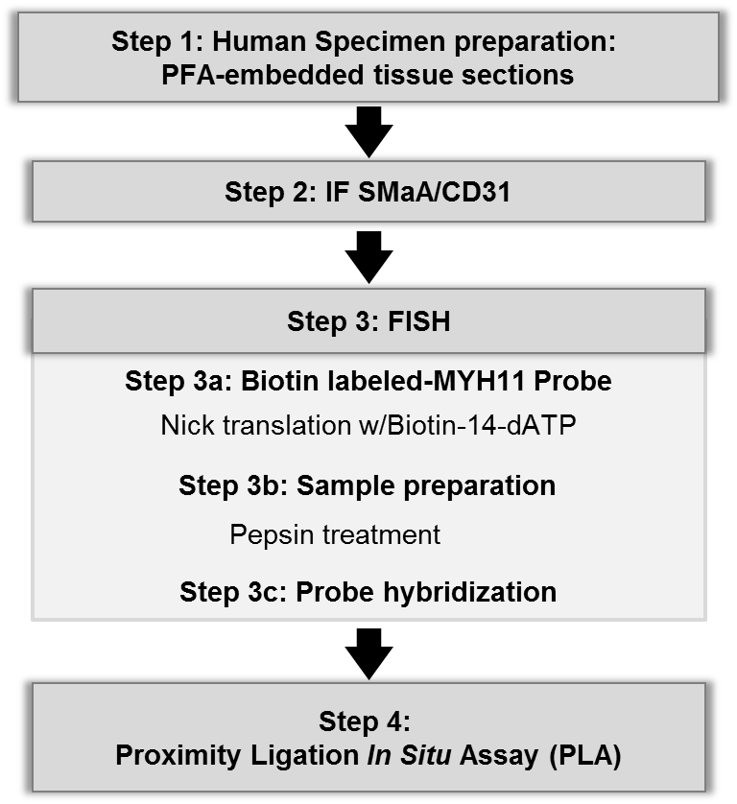

***DAY 1***

**Step 1: Human or mouse tissue sections**

PFA-fixed and paraffin-embedded tissues. Sections: 5µm. (Can try 10um but it is hard to have all important data and all PLA signals focused in the same plane).

**Step 2: Immunofluorescent staining**

***Deparaffinization and rehydration****:*

* Xylene: 2x5min
* EtOH 100% 2x5min
* EtOH 95% 2x5min
* EtOH 70%: 1x5min
* dH2O: 2x5min

Note: Workstation – tissue tek II.

***Antigen retrieval:***

- Prepare 320ml dH2O + 3ml Antigen unmasking solution

(Antigen Unmasking Solution, Vector, Burlingame, CA H-3300, low pH)

*Note: warm up unmasking sol in the 37°C water bath before use during Deparaffinization and rehydration*

- Microwave slides in solution above for 20 min. Keep covered. Stop at 15, 11, 7, 3, 1 minutes to top off container with dH20. Boiling is not a problem as long as slides never dry up. It is important to fill up all the spaces in the slide-carrying device so that heat is distributed evenly – use blank slides for this.

**1H cooling down** in the unmasking sol (simply leave container outside the microwave on the bench at RT). Put cover across (not fully open, not fully closed).

**Blocking:**

- Blot off excess solution from slides (avoid disturbing sample or drying tissue) and use hydrophobic pen to draw circles around samples (ImmEdges, Burlingame, CA. H-4000). These circles will contain solutions on the slides and keep them separate from solutions added to other tissue sections on the same slide.

- Incubate in PBS/FSG (3g FSG/500mL PBS 1X) + **Goat OR Horse serum** (100µl/ml – goat Sigma G6767) for 1H RT in a humidity chamber, sitting, not rocking. Always make fresh, vortex serum well before use. Usually 10mL is good for a whole experiment. In that case, 9mL PBS and 1mL serum.

FSG: fish skin gelatin. (Sigma G7765, in 45% water) Looks like honey. Weigh by pouring onto parafilm on a scale, then pour into PBS. Shake very well. Foam OK. In theory BSA can be another option here.

**Primary antibodies**.

Use vacuum trap and tip to remove blocking solution. No need to keep changing tip.

Dilution in PBS/FSG/serum. 1H RT (alternatively overnight 4°C)

Write in pencil on the slides what tissue gets what antibody combination.

Washes: PBS/FSG (or PBS/Tween for GFP staining). 3*5min

**Secondary antibodies**. Dilution in PBS/FSG/serum. 45min RT. After this step, slides must be protected from light. (or during primary if conjugated)

Washes in PBS/FSG 2*5min

*For QC: Stop here and just do IF:*

- 3rd round of staining with DAPI (mounting medium from PLA has DAPI already in it so hence why this step is skipped for full protocol).

- 10-15min 2x wash w/ PBS

Note: repeat the same including pepsin treatment after IF staining. The goal is to assess the integrity of the tissue and the strength of IF signal. Next repeat the same + PLA antibodies and see if you can still recognize

**Step 3: In situ Hybridization**

After the IF protocol… (continue to keep slides away from light!)

Immerse slides in 100% EtOH 10min, 70% EtOH (190 proof + DI water) 10min. (glass container)

Incubate slides in **1mM EDTA** pH8 20min at 40-45°C (use water bath of the bacterial bench). Coplin jar.

Incubate slides in **pepsin solution** (Sigma P7000-25G from porcine gastric mucosa), 15min at 37°C. Wash with PBS 5min at RT (Coplin jar) to remove debris while you prepare the probes.

*Note:* changing pH of pepsin solution as well as incubation time can be helpful for optimizing protocol in new samples.

|  |  |  |  |  |  |  |  |
| --- | --- | --- | --- | --- | --- | --- | --- |
| **Pepsin solution pH 4-4,5** | |  |  |  |  |  |  |
| Pepsin | 500mg |  |  |  |  |  |  |
| 1M TrisHCL pH8 | 5ml |  |  |  |  |  |  |
| 200mM CaCl2 | 2ml |  |  |  |  |  |  |
| 0,5M EDTA | 2ml |  |  |  |  |  |  |
| 5M NaCl | 200µl |  |  |  |  |  |  |
| H2O | qs 100ml | Adjust pH **BEFORE** adding the totality of H2O volume. | | | | | |
| Final vol | 100 ml |  |  |  |  |  |  |

Pepsin should be dissolved right before use – make sure you give enough time to allow for it to fully dissolve, however. The rest of reagents are stable at room temperature and do not need to be prepared fresh. As indicated, pH needs to be adjusted before adding the totality of the water volume.

**Probe denaturation:** Add hybridization buffer and Cot-1 DNA to the probe and heat 5 min at 80°C. (make sure heat block is pre-heated).

|  |  |  |  |  |  |  |  |  |
| --- | --- | --- | --- | --- | --- | --- | --- | --- |
| **Hybridization buffer** | µl |  | **Probe mixture** | µl |  |  |  |  |
| Formamide | 500 |  | Hybrid buffer | 7 |  |  |  |  |
| dextran sulfate 50% | 100 |  | Cot-1 DNA | 1 | Human or Mouse Cot-1 DNA | | |  |
| 20xSSC | 100 |  | probe | 2 (4) | The amount of probe can be | | |  |
| H2O | 300 |  | total | 10µl | adjusted depending of the tissue | | | |

Formamide from Fisher Sci BP 228-100 Super Pure Grade

Dextran sulfate sodium salt from Sigma. Hard to dissolve – keep aliquots at 4C for months.

Mouse Cot-1 DNA: Invitrogen cat # 18440-016

Human Cot-1 DNA: Invitrogen cat # 15279-011

Dry slides as much as possible to avoid diluting probes.

Add probe to slides ~10µl/slide, coverslip.

Hold cover with thumb and seal with nail polish. Let dry ~ 10 min

Incubate slides 3-5 min at 80°C by immersing them in a coplin jar with water already sitting in a heated water bath. Because the slides have been sealed with nail polish the water immersion will not be a problem.

Place slides in humidity chamber overnight @ 37°C.

***DAY 2***

Pull out gently the coverslip. Use a razor blade to break off the nail polish. Start at a corner and wedge the blade in then follow along the edges taking care not to disturb the samples. When removing the cover, avoid shearing and pull straight up and out.

Washes 3*15min in 2xSSC/0.1% NP-40 [1L: 100mL 20x SSC, 1mL NP-40, 900mL water]

Wash in PBS 1*5 min (mostly just to remove foam from previous buffer)

**Step 4: Proximity ligation assay (Duolink kit)**

Dry slides well and re-draw circles with hydrophobic pen

***Blocking*** w/ provided solution. 45 min RT

***Primary antibodies:*** H3K4dime (1/100) + biotin (1/100) in antibody dilution solution, 1mL usually good for whole exp. Ovenight 4°C.

Antibodies:

Anti-H3K9me2 Mouse monoclonal Millipore clone CMA303 cat # 05-1338 Lot # NG 1937357 (100ug)

Anti-H4ac Mouse monoclonal Millipore clone 3HH4-4C10 cat # 05-1355 Lot # NG 1936909 (100uL)

Anti-H3K27me3 [mAbcam 6002] – ChIP grade (ab6002)

Abcam rabbit for Biotin.

***DAY 3***

Solutions A and B are prepared from pouches provided by DuoLink kit. They keep well on the shelf.

Washes Sol A. 3*5min. (fluid bubble over tissue section)

**Secondary antibodies (PLA probe antibodies, PLUS and MINUS).** Dilution 1:5 in antibody diluent. 1H at 37°C in humidity chamber.

Washes in Wash Buffer A. 3*5min. (fluid bubble over tissue section)

**Ligation.** Dilute ligation Stock 1:5 in water. Add ligase 1:40. Mix. 30 min at 37°C in humidity chamber.

Washes in Wash Buffer A. 3*5min. (fluid bubble over tissue section)

**Amplification.** Dilute amplification stock 1:5 in water. Add polymerase 1:80. Mix. 100 min at 37°C in humidity chamber.

Final washes: 3*10min with Wash Buffer B. Wash slides in 0.01X Wash buffer B (mostly water) for 5 min. Since we no longer need to add expensive reagents in small drops it’s ok to wash in the large glass container and get the whole slide wet.

**Mount slides** with Duolink II mounting medium. Coverslip. Wait AT LEAST 30min before looking under fluorescent microscope. Keep slides at 4°C.

Suggestion: Place cover on bench, facing up. Apply a column of mounting media through the middle, avoiding bubbles. Then, hold slide with tissue at a 90-degree angle and align. Gently let slide fall onto cover and watch mounting media spread. Make sure there are no bubbles over the tissue sections. Media can be moved around with the rubber end of a pencil by gently applying pressure on mounted slide.

Suggestions for possible controls: skip secondary (PLA) antibody and do ligation etc. another possibility, skip primary antibody (or use IgG) and follow with the rest.

***APPENDIX: Nick Translation to prepare Biotin-labeled probes***

Amplify a 1.5-2kb region of interest by PCR and run on an agarose gel. Cut bands and perform gel extraction. Ligation into a TOPO vector. Cell transformation (Invitrogen TOPO TA Cloning Kit 25-0185 Version J, 24 july 2006). Spread cells on Agar plates w/ ampicillin + Xgal. Overnight 37°C. White/blue screening. Pick white colonies (integration of the pcr fragment into the vector). Minipreps. OD. Use 1µg of plasmid for Nick translation.

This part is tricky and it may randomly not work. It is critical to run the resulting fragments on a 1.5-2% agarose gel and check that there is a smear around 200-300bp. It is important to have small fragments because we are working with samples that (hopefully) have well preserved chromatin structure and thus it would be too hard to hybridize larger fragments.

Need to purchase Biotin-1,4-dATP from Invitrogen (Cat. No. 19524-016) 50nmol (0.4 mM). Also, order extra dNTPs (set, not mix) from Roche, as there tend to not be enough in the kit. These will come at a higher concentration to it is important to dilute and aliquot them so they are at 0.4mM as well.



PCR machine settings: 2H at 16°C. Stop the reaction by addition of EDTA: 1.25µL of 0.5M EDTA in 25µL.

Probes are ready to use. Store at -20°C. They are good for a couple months. It’s convenient to aliquot them at 1ug in 25ul per tube.